**A Multivariate Time Series Analysis with Vector-Auto-Regression(VAR) model to study the relationship between USD/INR Currency, Crude Oil and Gold Rates.**

**Introduction :**

The international trade value statistics contribute to the development of the economy. Indian economy is influenced by Gold hence with that variable the common trade value currency variable USD was chosen with Crude Oil being influenced by it. Over the years these three variables consisted a dynamic relationship and with the COVID impact on various trades amongst the countries and thereby affecting the economy, I decided to take three variables which are USD/INR Currency, Crude Oil and Gold rates to study the relation amongst them. The data was captured from Yahoo finance on the weekly basis from 12th June 2017 to 15th June 2020 . As time being the factor and to find relations between multiple variable variables termed as “Multivariate time series” analysis a VAR model was chosen with various statistical tests performed.

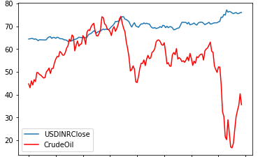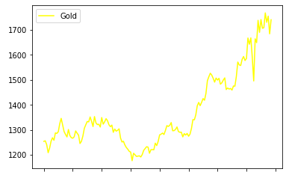

**Statistical tests performed and modelling :**

Moving on to the assumption based on the data, the gold showed positive correlation with the USD/INR currency rate. The crude oil showed a high negative correlation with Gold. Similarly there was a little negative correlation between USD/INR and Crude Oil.

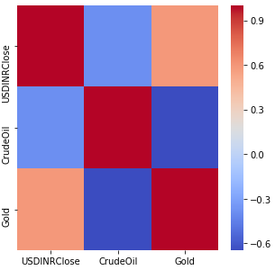

After understanding the data, various statistical tests were performed to observe the causation in the variables, how statistically strong the variables are related and if the series is stationary to perform a multivariate analysis. For the causality amongst the variables a granger’s causality test was performed on the data. If the significance value is less than 0.05 then it can be concluded that the variable is causing the other. It can be observed Crude Oil - USDINRClose and Gold – Crude Oil show the causality between them. The USDINRClose and Gold do violate the significance level but still taken into analysis to study the relationship amongst the three variables.

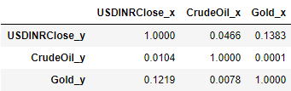

A Johansen co-integration test was performed to test the long-run relationship between the variables . The long-run relationship consists of the cyclic events occurring over the time which can be captured by a co-integration test but not by correlation. As the co-integration was absent amongst the variables, the VECM model was discarded and VAR model was chosen for a short-run relationships.

To run a VAR model the series needs to be stationary, to check if the series is stationary an Augmented Dickey-Fuller test was performed on each variable. If the significance value is less than 0.05 then it can be considered stationary. As the series was not stationary, differencing was performed once and the series was made stationary.

While applying the VAR model, a minimum lag of order 2 AIC was chosen, which is a general practice to observe the change in the relation from that point. The correlation matrix of the residuals was obtained from the model results. It can be observed that the Crude Oil has a negative relationship with USDINRClose rate but a positive relation with Gold. The Gold variable also has a positive relationship with USDINRClose.

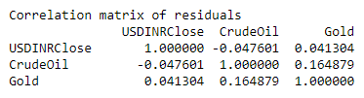

**Conclusion:**

As observed amid the COVID crisis the USDINR currency rate is inversely related with Crude oil which can be seen in today’s world as crude oil prices dropped to a record low per barrel and the cost of USD reached to 76 INR and could go more upwards. Gold shows a positive relation with currency where there is an increase in the rate as rupee falls for a dollar.

# Bibliography

(n.d.). Retrieved from ResearchGate: https://www.researchgate.net/post/what_is_Cointegration

(n.d.). Retrieved from https://economictimes.indiatimes.com/wealth/invest/how-does-gold-impact-the-economy/articleshow/64538078.cms?from=mdr

Adeleye, B. N. (2018). *cruncheconometrics*. Retrieved from http://cruncheconometrix.blogspot.com/2018/03/time-series-analysis-lecture-4-part-1.html

Chang, H.-F. H.-C.-C. (2013). Interactive relationships between crude oil prices, gold prices, and the NT–US dollar exchange rate—A Taiwan study. Energy Policy. *ScienceDirect*.

K. S. Sujit, B. R. (2011). STUDY ON DYNAMIC RELATIONSHIP AMONG GOLD PRICE, OIL PRICE, EXCHANGE RATE AND STOCK MARKET RETURNS. *International Journal of Applied Business and Economic Research,*.

*Machine Learning Plus*. (n.d.). Retrieved from https://www.machinelearningplus.com/time-series/vector-autoregression-examples-python/